1 | Contest Problems Upsolving
A. Lower Bound-STL
Problem Statement
You are given a sorted array of integers and multiple queries. For each query, you must check whether the number exists in the array. If it exists, print "Yes" with its first 1-based index. If it does not exist, print "No" along with the index of the smallest number greater than it. Since the array is sorted, this is efficiently solved using lower bound (binary search)
Theory / Approach
The solution uses lower bound (binary search) to find the first position where the given number can be inserted while maintaining sorted order. If the element at that position matches the query value, it is present in the array. Otherwise, that position gives the index of the next greater element. This allows each query to be answered efficiently in logarithmic time
Code
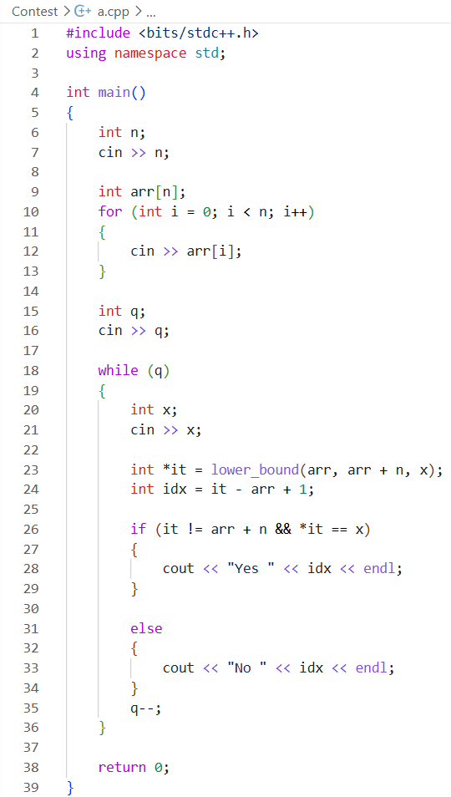
Output
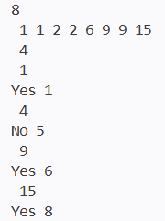
Verdict
Discussion
- Time Complexity: O((n + q)\log n), as each query uses binary search
- Space Complexity: O(n), for storing the input array

B. Subarray Division
Problem Statement
You are given an array representing chocolate squares and two values: a target sum (birth day) and a segment length (birth month). You need to count how many contiguous segments of size equal to the birth month have a sum equal to the birth day
Theory / Approach
The solution uses a sliding window technique. First, compute the sum of the first m elements. Then slide the window one step at a time by removing the leftmost element and adding the next element. At each step, check if the current window sum equals the target d. This avoids recomputing sums from scratch and ensures an efficient linear scan through the array
Code
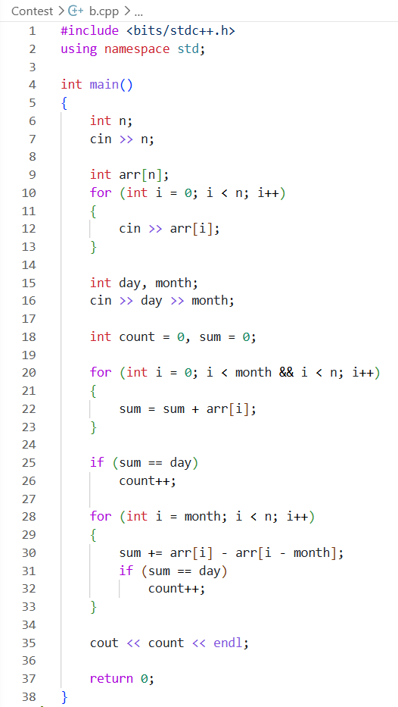
Output
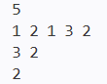
Verdict
Discussion
- Time Complexity: O(n), since each element is processed once using sliding window
- Space Complexity: O(1), as only a few variables are used for computation

C. Sherlock and Anagrams
Problem Statement
You are given a string and need to find how many pairs of substrings are anagrams of each other. Two substrings form a valid pair if one can be rearranged to form the other. The task is to count all such unordered anagrammatic pairs in the given string
Theory / Approach
The solution generates all possible substrings and represents each substring using a frequency signature of 26 characters (count of each letter). Substrings with the same frequency signature are anagrams. We store each signature in a map and count occurrences. Finally, for each group of identical signatures, we compute pairs using the formula (c \times (c - 1) / 2), where (c) is the frequency of that signature
Code
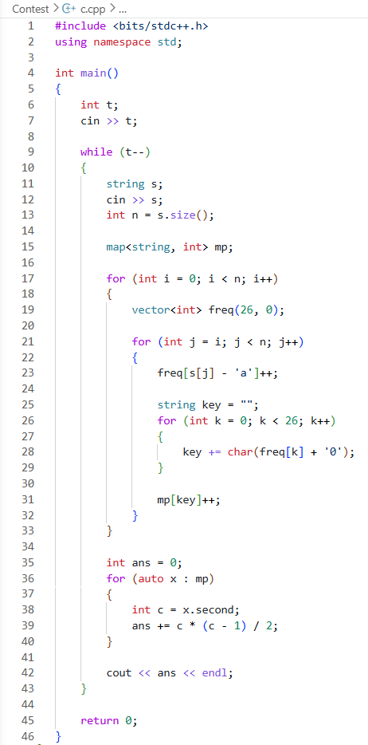
Output
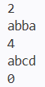
Verdict
Discussion
- Time Complexity: O(n^2), due to generating all substrings and building frequency keys
- Space Complexity: O(n^2), for storing substring signatures in the map

D. Task Scheduling
Problem Statement
You are given a list of tasks where each task has a processing time and a deadline. Tasks can be split and resumed later. You must schedule all tasks in a way that minimizes the maximum delay (lateness), where lateness is the amount by which completion time exceeds the deadline. For each prefix of tasks, you must Output the minimum possible maximum lateness
Theory / Approach
The optimal strategy for minimizing maximum lateness is to process tasks in ascending order of deadlines (Earliest Deadline First idea). However, because tasks can be split and resumed, the problem effectively reduces to tracking how completion times accumulate relative to deadlines. For each prefix, we simulate scheduling under optimal ordering and compute the maximum overshoot among tasks
Discussion
This problem was not successfully solved during the lab contest due to its high conceptual complexity and non-trivial scheduling behavior. The main difficulty was understanding how task splitting affects completion time and how to correctly model an optimal schedule. Another challenge was determining how to efficiently compute the maximum lateness for each prefix without fully simulating all possible interleavings. The combination of greedy scheduling intuition and prefix-wise evaluation made it difficult to implement correctly within the time limit

2 | Prime Factorization (2 Problems)
- T-primes
Problem Statement
We are given multiple integers and need to determine for each whether it is a T-prime, meaning it has exactly three distinct positive divisors. For every number, we print "YES" if it is T-prime, otherwise "NO"
Theory / Approach
A number has exactly three divisors only when it is a perfect square of a prime number. So instead of directly counting divisors, we check two conditions: (1) the number must be a perfect square, and (2) its square root must be a prime number. We first precompute all primes up to (10^6) using the Sieve of Eratosthenes. Then, for each query number, we compute its square root and verify both conditions efficiently
Code
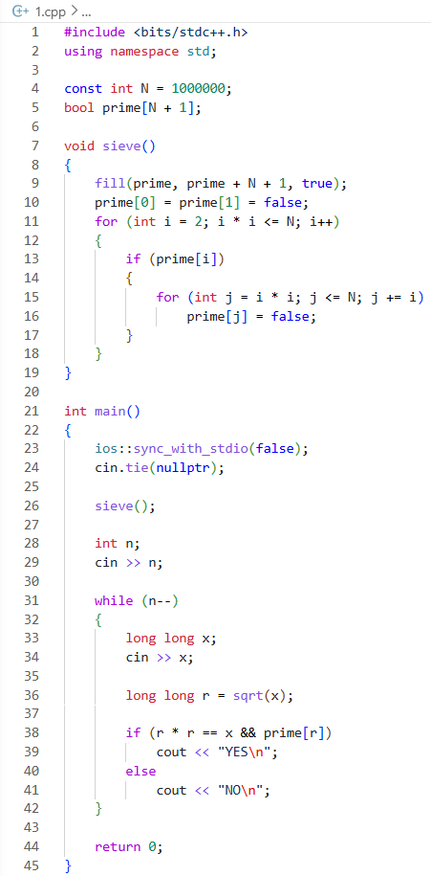
Output
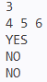
Verdict
Discussion
- Time Complexity: O(n + N)
- Space Complexity: O(N) for prime sieve array

- Game 23
Problem Statement
We are given two integers n and m. We can transform n into m only by multiplying it by 2 or 3 any number of times. We need to find the minimum number of operations required, or print -1 if it is not possible
Theory / Approach
To check feasibility, we first verify whether m is divisible by n. If not, transformation is impossible. Then we reduce the ratio m / n step by step by dividing out all factors of 2 and 3. Each division counts as one operation. If after removing all 2s and 3s the result becomes 1, transformation is valid; otherwise, it is impossible. The total number of divisions gives the answer
Code
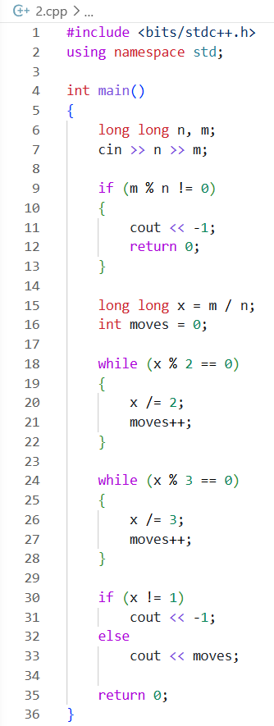
Output
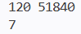
Verdict
Discussion
- Time Complexity: O(log n)
- Space Complexity: O(1)

3 | Euclidean Practice (1 Problem)
- Maximum Sum of Digits
Problem Statement
We are given an integer n and must split it into two non-negative integers a and b such that a + b = n. The goal is to maximize the sum of digits of a and b combined, i.e., S(a) + S(b)
Theory / Approach
Instead of trying all splits, we use a greedy idea: the optimal split occurs when we distribute digits in a way that avoids carrying during addition. A key observation is that maximizing digit sums is achieved when we break n into two numbers where digits are balanced greedily from right to left. Practically, we iterate through digits and construct a and b so their digit-wise sum never exceeds 9, maximizing total digit contribution without carry loss
Code
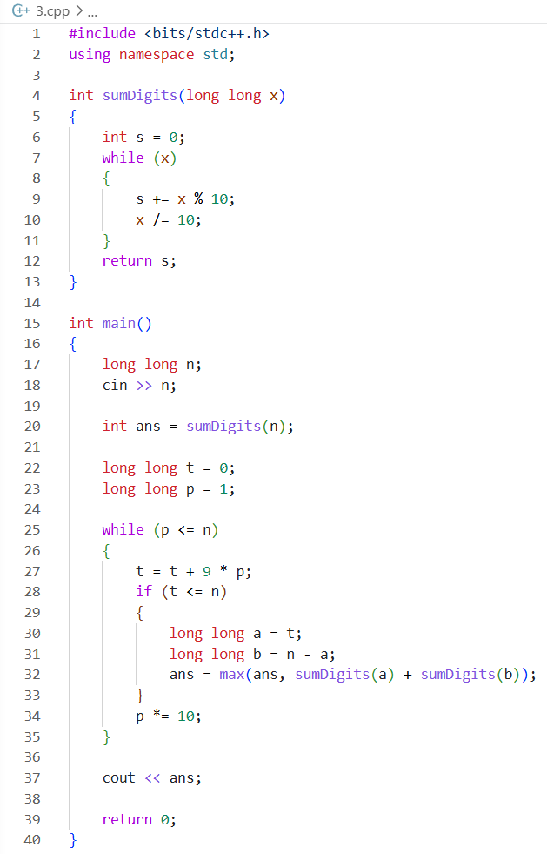
Output
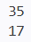
Verdict
Discussion
- Time Complexity: O(d), where d is number of digits in n
- Space Complexity: O(d) for digit storage

4 | Sieve (3 Problem)
1. Sherlock and his girlfriend
Problem Statement
Given n jewelry pieces with prices 2, 3, 4, ..., n+1. Color them so that if price x is a prime divisor of price y, they have different colors. Minimize the number of colors used
Theory / Approach
- If n ≤ 2, only 1 color is needed because no prime divides another prime.
- If n ≥ 3, 2 colors suffice:
- Color 1 for all prime numbers
- Color 2 for all composite numbers
- A composite number always has a prime divisor, so it will always have a different color than its prime factor.
Code
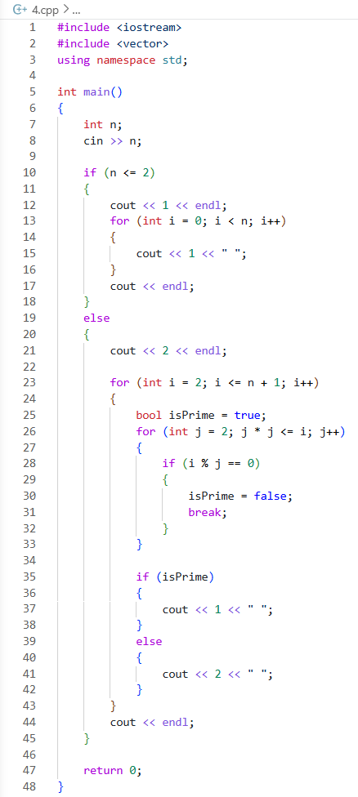
Output
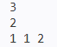
Verdict
Discussion
• Time Complexity: O(n√n), primality check for each number up to n+1
• Space Complexity: O(1)

2. Next Test
Problem Statement
Given n distinct positive integers (test indices), find the smallest positive integer that is not present in the list.
Theory / Approach
- Sort the array of existing test indices
- Iterate from 1 upwards, checking if each number exists in the sorted array
- The first missing number is the answer
- Since n ≤ 3000 and a_i ≤ 3000, the answer will be at most 3001
Code
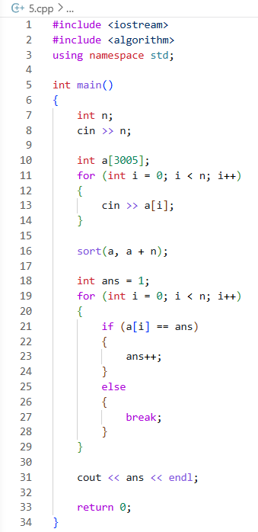
Output
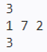
Verdict
Discussion
• Time Complexity: O(n log n), due to sorting
• Space Complexity: O(n)
3. Olesya and Rodion
Problem Statement
Given n (number of digits) and t (divisor, 2 ≤ t ≤ 10), find an n-digit positive integer (no leading zeros) divisible by t. If none exists, print -1
Theory / Approach
- If t = 10, the number must end with 0. For n = 1, an n-digit number ending with 0 is just "0" which is not positive. So for n = 1 and t = 10, answer is -1
- For t = 10 and n ≥ 2, print '1' followed by (n-1) zeros
- For all other t (2-9), construct an n-digit number by writing t repeated n times. This number will be divisible by t
- Special case: If t = 10 and n = 1 → -1
Code
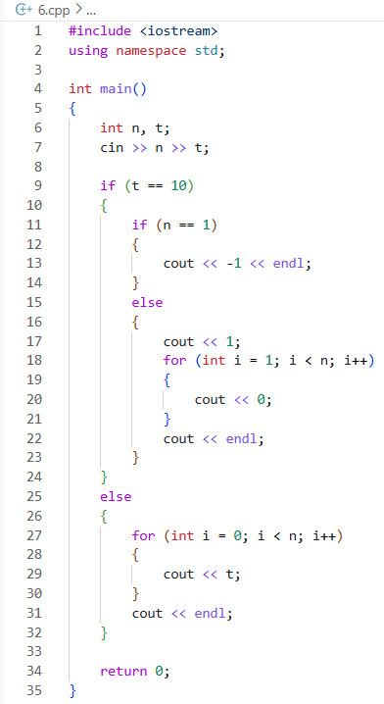
Output
Verdict
Discussion
- Time Complexity: O(n)
- Space Complexity: O(1)

4 | Cumulative Sum (2 Problems)
1. Kuriyama Mirai's Stones
Problem Statement
Given n stones with costs v[i]. Two types of queries:
- Type 1: sum of costs from index l to r in the original order
- Type 2: sum of costs from index l to r in sorted (non-decreasing) order
Answer m queries efficiently
Theory / Approach
- Use prefix sum arrays for O(1) range sum queries
- Create prefix sum array `prefix_original` where prefix_original[i] = sum of v[1..i]
- Sort v to get u (non-decreasing order)
- Create prefix sum array `prefix_sorted` where prefix_sorted[i] = sum of u[1..i]
- For each query:
- Type 1: Output prefix_original[r] - prefix_original[l-1]
- Type 2: Output prefix_sorted[r] - prefix_sorted[l-1]
- Use long long to avoid overflow (vi up to 1e9, n up to 1e5 → sum up to 1e14)

Code
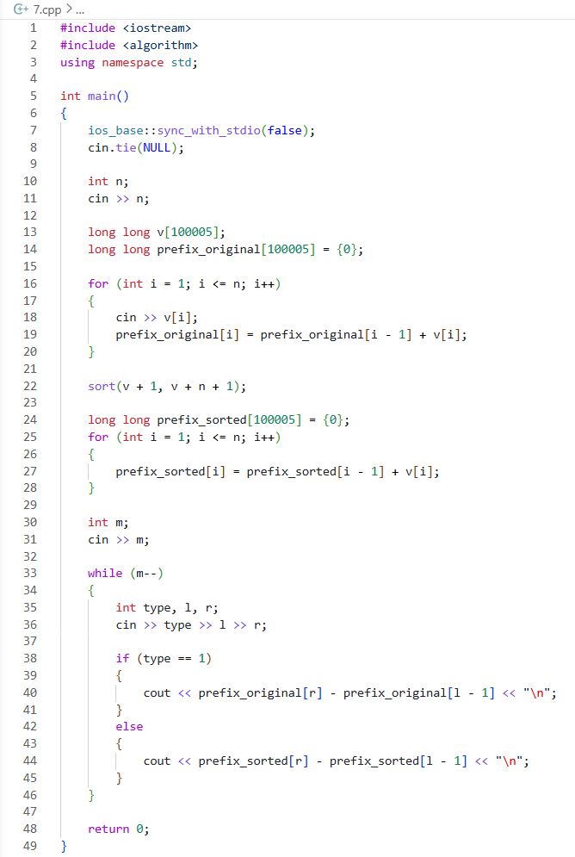
Output
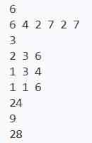
Verdict
Discussion
- Time Complexity: O(n log n + m), sorting takes O(n log n), queries take O(1) each
- Space Complexity: O(n), for storing prefix sums

2. Fence
Problem Statement
Given n planks with heights h[i], find the starting index j of k consecutive planks (j to j+k-1) with the minimum sum of heights. If multiple answers exist, print any
Theory / Approach
- Use sliding window technique to calculate sum of each window of size k in O(n)
- Initialize sum of first k planks (indices 0 to k-1)
- Slide window by subtracting leftmost element and adding next element
- Track minimum sum and its starting index (1-based Output)
- Since hi ≤ 100, sums fit in int
Code
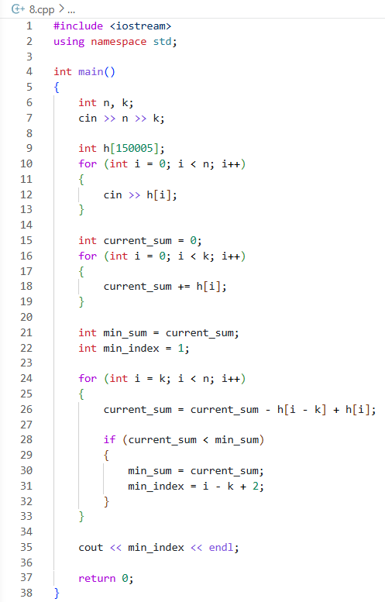
Output
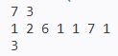
Verdict
Discussion
- Time Complexity: O(n), single pass through the array
- Space Complexity: O(n), for storing heights (can be O(1) by processing on the fly)

5 | Greedy (3 Problems)
1. Kefa and First Steps
Problem Statement
Given an array a of length n, find the length of the longest contiguous non-decreasing subsegment (i.e., each element is >= the previous one)
Theory / Approach
- Traverse the array once, keeping track of current non-decreasing segment length
- Start with current_length = 1 (first element)
- For i from 1 to n-1:
- If a[i] >= a[i-1], increment current_length
- Else, reset current_length = 1
- Update max_length = max(max_length, current_length)
- Output max_length
Code
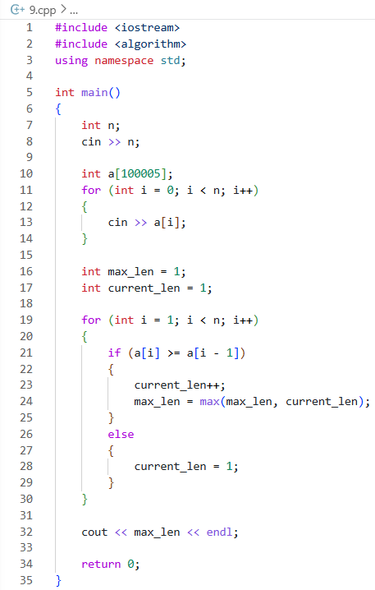
Output
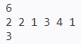
Verdict
Discussion
• Time Complexity: O(n), single pass through the array
• Space Complexity: O(n), for storing array (can be O(1) by processing on the fly)
2. Puzzles
Problem Statement
Given n students and m puzzles with piece counts f[i], choose exactly n puzzles such that the difference between the maximum and minimum piece count among chosen puzzles is minimized. Output that minimum difference
Theory / Approach
- Sort the array of puzzle piece counts
- Since we need n consecutive puzzles in sorted order to minimize max-min difference (any gap would only increase difference)
- Use sliding window of size n over the sorted array
- For each window, compute difference = f[i+n-1] - f[i]
- Track the minimum difference across all windows
- Return the minimum
Code
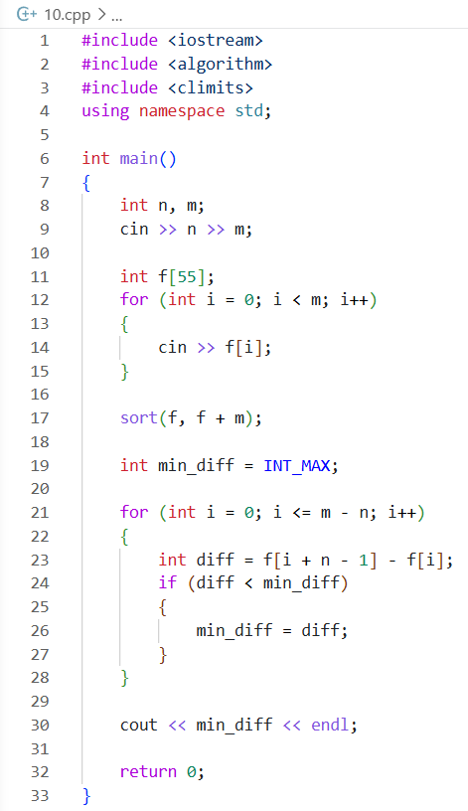
Output
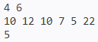
Verdict
Discussion
- Time Complexity: O(m log m), due to sorting
- Space Complexity: O(m), for storing array

3. Boredom
Problem Statement
Given a sequence of n integers, in one move you can pick a number ak, delete all occurrences of ak, ak+1, and ak-1 from the sequence, and gain ak points. Find the maximum total points possible
Theory / Approach
- This is a dynamic programming problem similar to House Robber
- First, count frequency of each value (up to 10^5)
- Let dp[i] = maximum points achievable considering numbers from 1 to i
- Transition:
- If we take value i: points = freq[i] * i + dp[i-2] (since i-1 becomes unavailable)
- If we skip value i: points = dp[i-1]
- dp[i] = max(dp[i-1], dp[i-2] + freq[i] * i)
- Base cases:
- dp[0] = 0
- dp[1] = freq[1] * 1
- Answer is dp[max_value]
Code
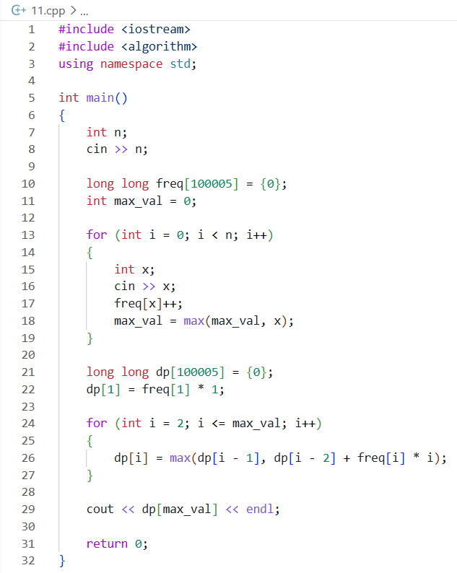
Output
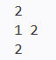

Verdict
Discussion
- Time Complexity: O(n + max_val), where max_val ≤ 10^5
- Space Complexity: O(max_val), for frequency and dp arrays

